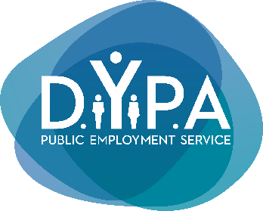  HEAD OFFICE |  | Press Release
Department of Communication &
Public Relations
Athens, 04.02.2024

DYPA and "Margarita" support the integration of persons with mental disability into the labour market

The Governor of the Greek Public Employment Service (DYPA), Spiros Protopsaltis, and the Head of the Margarita Vocational Training Centre Management Board (VTC Margarita), Vasilis Tsokopoulos, signed today a Memorandum of Understanding.

The Memorandum aims at the cooperation of the two institutions for the implementation of actions that tackle the obstacles citizens with mental disability and neurodevelopmental disorders face in developing skills and finding a suitable job. More specifically, the MoU provides for the exchange of information and expertise, the utilisation of common networks and the promotion of unemployed persons belonging to this vulnerable social group into the open labour market with the support of the DYPA Special Social Groups Offices (EKO).

DYPA Governor, Spiros Protopsaltis, stated: "Our cooperation with the Margarita Vocational Training Centre aims at the exchange of expertise and the implementation of joint initiatives that will lead to the development of vocational skills for unemployed persons with mental disability and neurodevelopmental disorders that will lead in turn to suitable jobs. Signing this MoU today highlights the emphasis DYPA places on supporting our fellow citizens belonging to the most vulnerable social groups, facilitating their effort to integrate into the labour market. DYPA wants an inclusive labour market, a labour market for all".

The Head of the Margarita Vocational Training Centre Management Board, Vasilis Tsokopoulos, stated: "The Memorandum of Understanding between the Margarita Vocational Training Centre and DYPA will offer the framework for the development of vocational training programmes for persons with neurodevelopmental disorders which will provide them with the necessary skills to find work and become self-sufficient. It is of great importance the fact that DYPA actively supports persons with disabilities' right to work".

